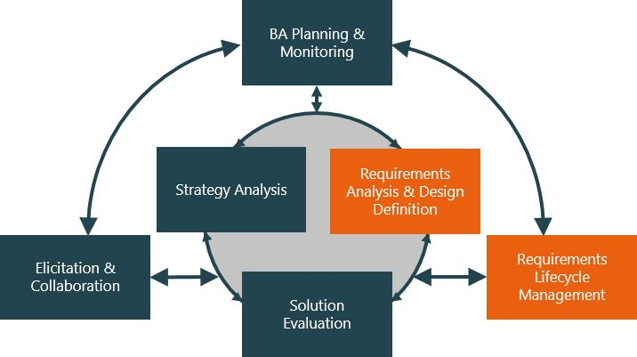

**Evaluate and communicate business requirements**

18219 | Sourng

|  |  |  |  |
| --- | --- | --- | --- |
| Name of Student | Sourng Ly | ID | 18219 |

# Assessment –

# Research & Questioning

Contents

Assessment – 1

Research & Questioning 1

***Instructions:*** 1

***Business Scenario*** 3

***Task 1: Determine support areas*** 4

***Task 2: Identify stakeholders*** 5

***Task 3: Develop support procedures*** 5

***Task 4: Assign Support Personnel*** 8

***Task 5: Short Answer Questions*** 9

***Task 6: Multiple Choice Questions*** 10

Index 16

#### View My Web Support:

<https://sourngma.github.io/EVT3/#myPage>

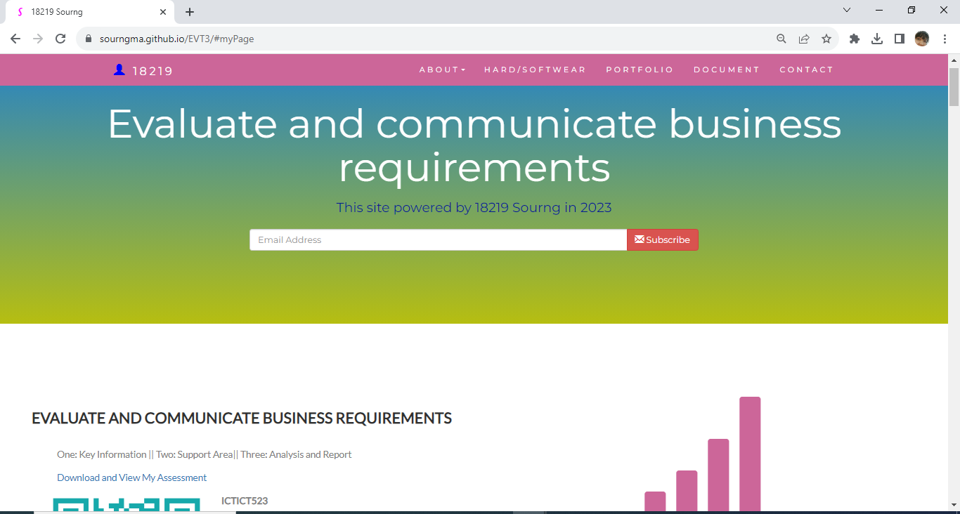

#### or

<https://wellsjohn220.wixsite.com/evaluate>

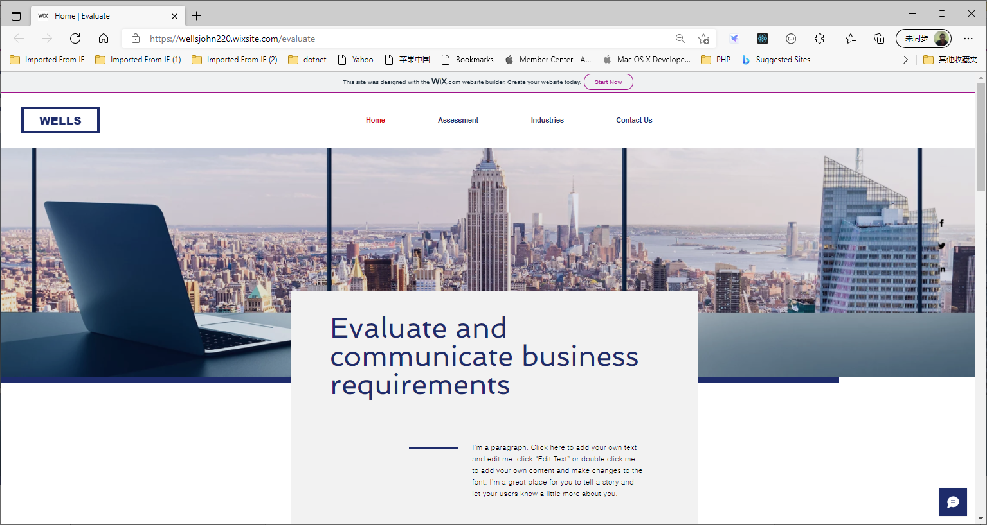

#### *Instructions:*

This assessment is to be completed individually. In this assessment you will be working through a number of written tasks based on case scenarios or research that relate directly to each element of competency for this cluster. Outlined below is information on how each of the tasks relates the element of competency covered.

Learn how to make Google Form: <https://www.youtube.com/watch?v=BtoOHhA3aPQ&t=4s>

Your tasks:

#### *Business Scenario*

D&K Books Pty Ltd is a bookstore owned by Mr. Dean Kerr. The business occupies two levels of an office building connected by escalators and lifts. D&K Books employs approximately six sales staff, one operation manager, two administrative officers, a bookkeeper and a marketing manager. They have an Ethernet network consisting of ten PCs (Intel I3 Desktop cloned), two switches, a router and three printers. They use the QuickBooks software to manage their entire business, including sales, inventory, ordering, accounts receivable, accounts payable, payroll and employee management. They also have two EFTPOS terminals one on each floor.

D&K Books has a Linux server that stores all of the data including the QuickBooks database. The server is backed up to tape regularly. They also have a website (hosted on an Australian ISP’s server, dynamic and static pages using asp.net) on which customers can browse the product catalogue and view current specials. They also lease a telephone system from Live Telecoms. The PABX (phone system) consists of a main switchboard and five remote phones with three incoming lines and a message-on-hold queue system.

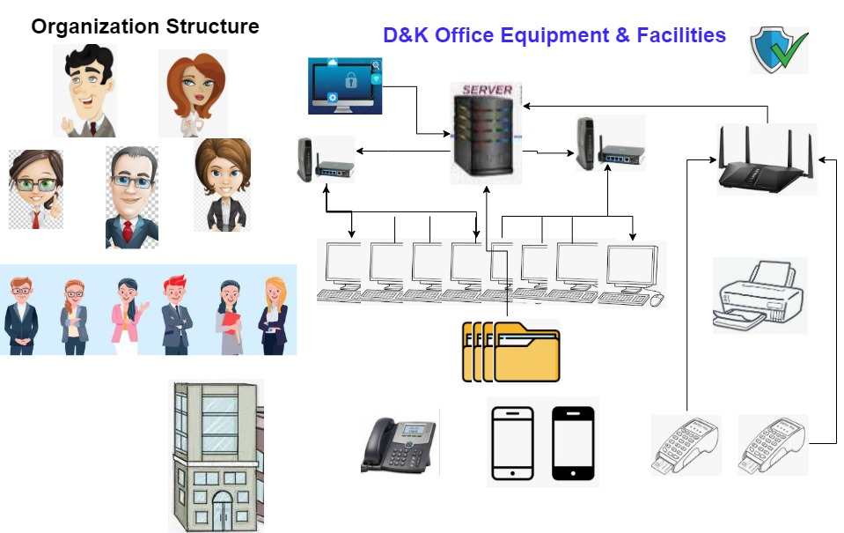

Good network system, you need setup at least:

|  |  |
| --- | --- |
| Hard ware | Software |
| Server X 1 | Window Server |
| Computer X 8 | Windows |
| Printer X 1 | SQL server |
| Telephone X 8 | Virus Protection |
| Modern X 2 | MS office |
| Network Cable | Eftpos machine More… |

#### *Task 1: Determine support areas*

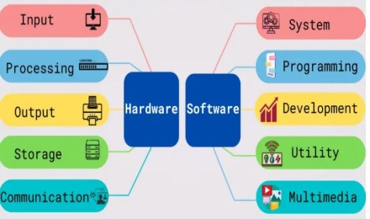Identify information technology (HW and SW) and list the technology in use in D&K Books and consider the following:

* What sort of support does the technology require?
* Who is likely to provide this support?
* Does the support arrangement already exist?

Present your answer in a table such as the one below:

|  |  |  |  |  |
| --- | --- | --- | --- | --- |
| **Technology** | **Description** | **Support Required** | **Provider** | **Support Already exists? (Yes/No)** |
| QuickBooks Software | software that keeps track of all accounts, stock, GST, etc. | customisation, training, upgrades, bug fixes (patching), user support | [www.intuit.com.au](http://www.intuit.com.au)  <https://quickbooks.intuit.com/partners/>  <https://www.fourlane.com/quickbooks-solution-provider/> | No |
| PC’s | Intel I3 Desktop cloned | upgrades, repairs, troubleshooting, maintenance, backup, customisation, network to link | [www.officework.com.au](http://www.officework.com.au)  [www.binglee.com.au](http://www.binglee.com.au)  www.jbhifi.com.au | No. Need find one person to do this job |
| Printers | Google Print, WiFi direct and ePrint functionality | Cable or wireless is available. Support all devices and easy access or connect | [www.officework.com.au](http://www.officework.com.au)  [www.binglee.com.au](http://www.binglee.com.au)  www.jbhifi.com.au | it’s easy and automatically connect to devices |
| IconExperience » V-Collection » Server Icon **Server** | Linux Server with tape backup  May need upgrade to hard disk backup | User account management, security policy implementation, home folder management, permissions management, backup and restore, operating system patching, software installation | [www.dell.com](http://www.dell.com)  [www.mwave.com.au](http://www.mwave.com.au)  [www.cisco.com](http://www.cisco.com)  www.pclan.com.au | No |
| EFTPOS | Easy to use | No need | shop | Yes |
| Telephone system | Low cost | Phone company | Telstra | Yes |
| Website | Low cost | Yes | Godaddy | Yes |
| Network | wireless | No external | No | No |

Please review my website: <https://sourngma.github.io/EVT3/#businesscase>

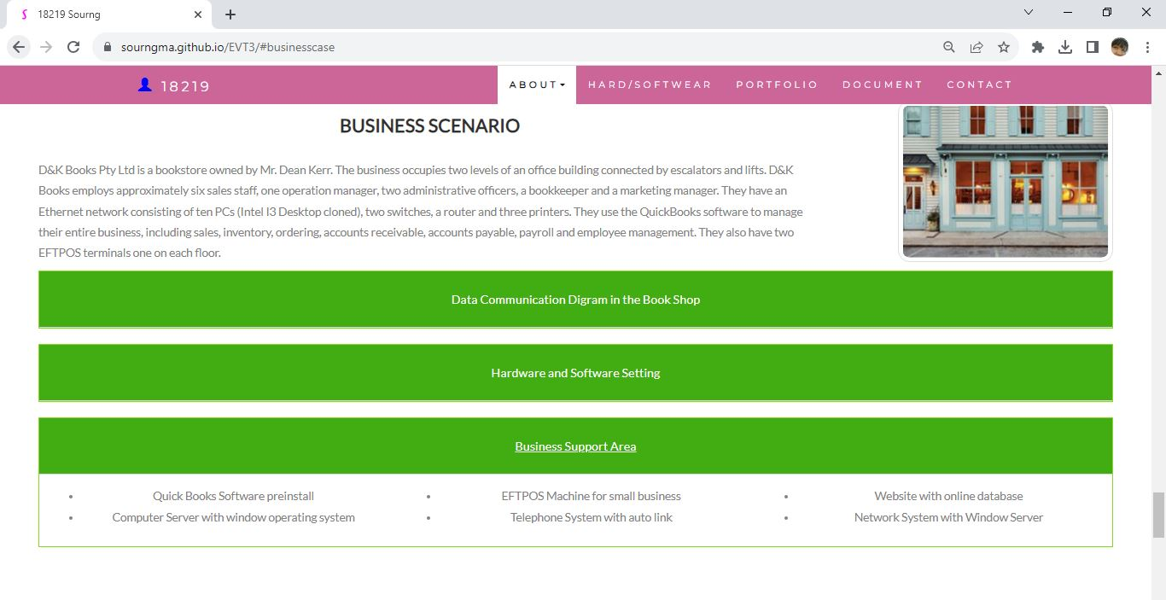

#### *Task 2: Identify stakeholders*

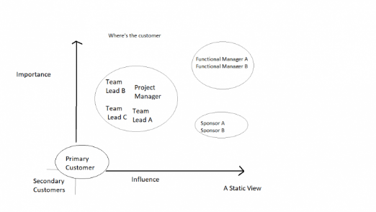 Identify stakeholders related in D&K Books system

All the staffs (the business owner, the relevant manager, the local workers and the remote workers) are stakeholders

Your comment: Yes, they are stakeholders because they are involved all the workflow in the business.

#### *Task 3: Develop support procedures*

1. Describe one positive and one negative experience you have had when seeking assistance from a telecommunication company, an ISP or a computer supplier. Your experience may be via telephone, email or even voice recognition.

|  |  |  |
| --- | --- | --- |
| Type | Positive | Negative |
| Telephone | Easy to get answer and talk to real person | On phone long waiting queue, Document provide and identify on phone procedure |
| Email | Document, Picture, words or any media | Have to wait for feedback or don’t getting reply on time. |
| Go to company | Face to face get answer | Cost time and money on trip |
| Livechat | Easy access to services and get answers shortly | Concern privacy is leaking or scam due to ask for personal information. Take time or freeze if poor internet. |

1. Using the experiences described above please answer the following questions.
   1. What support aspects were professional and/or unprofessional?
   2. How long did the support process take?
   3. Were the steps logical?
   4. Did they solve your problem?
   5. Was the call deflected to another area?

|  |  |  |
| --- | --- | --- |
| Items | professional | unprofessional |
| What support aspects | Friendly, Listening, provide wise advices fit the conditions | Don’t know your customer exactly |
| How long | Very quick and efficiency | Waiting and waiting, can’t provide the suitable solution |
| Steps logical | Yes | No |
| Solve | Good | Can not |
| Another area | If has, need solve | If has, do not care |

Using feedback form or Google survey form.

Here is the very simple survey demo:

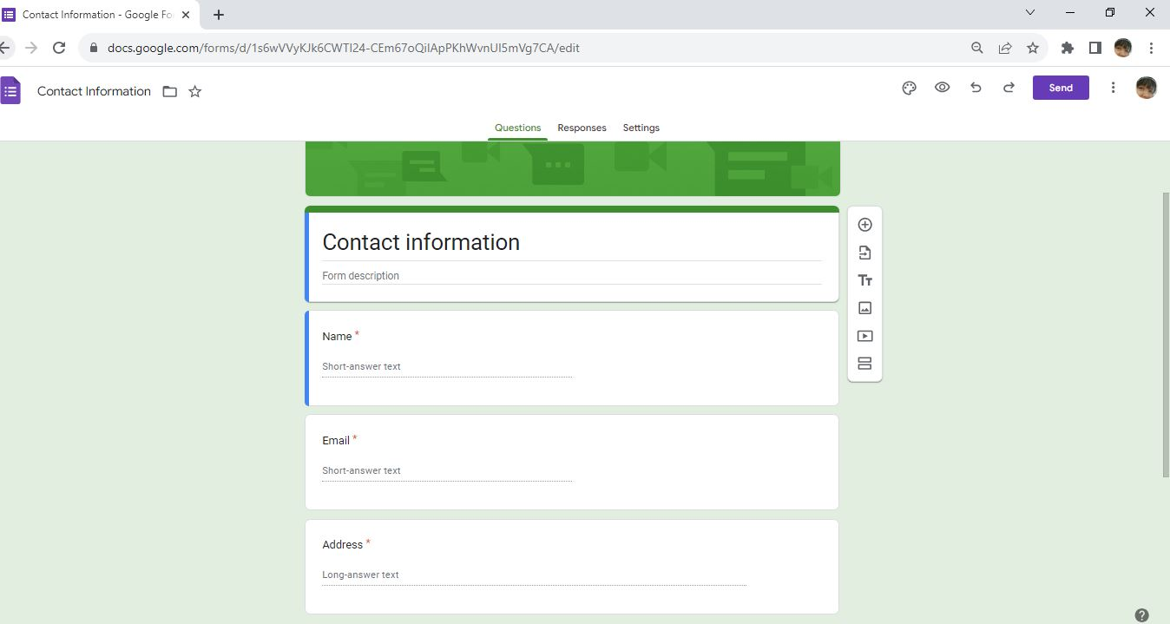

After I tested my friends, I could get nice response like:

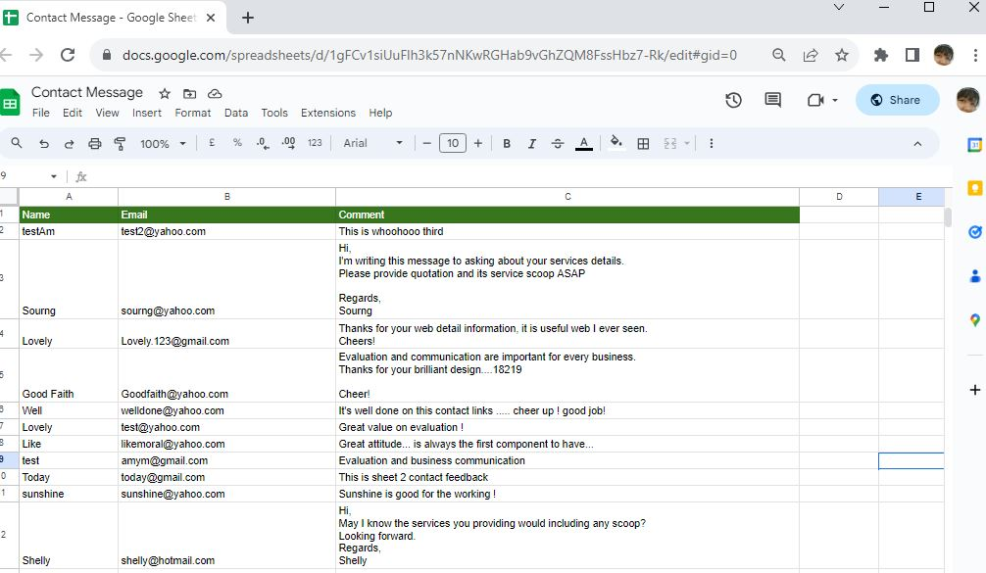

Or using link string:

https://docs.google.com/spreadsheets/d/1gFCv1siUuFlh3k57nNKwRGHab9vGhZQM8FssHbz7-Rk/edit?usp=sharing

Please review my website: <https://sourngma.github.io/EVT3/#taskthree>

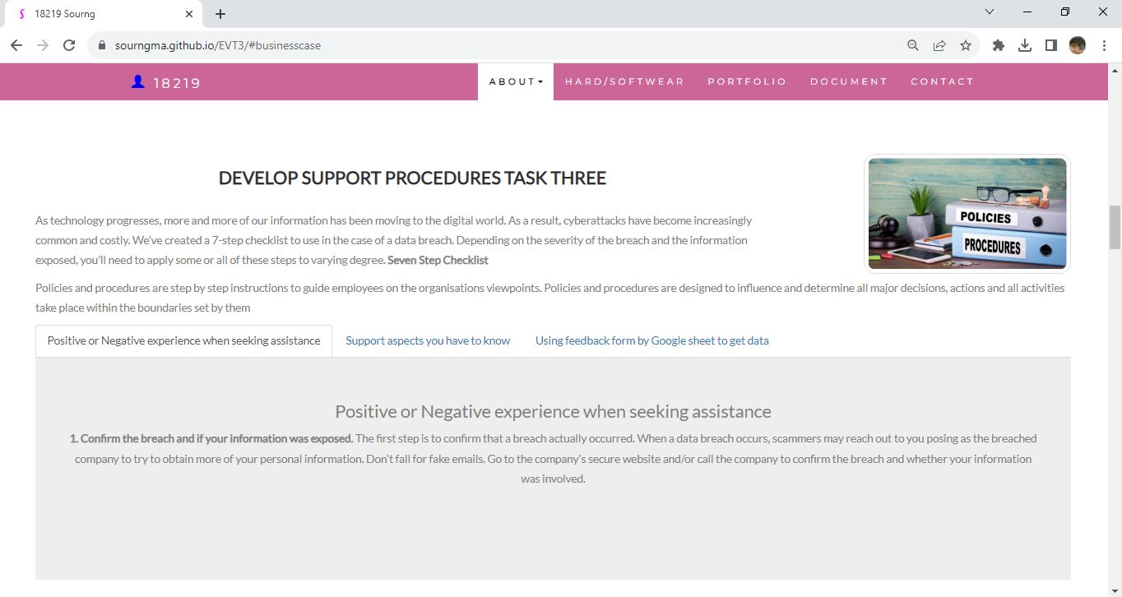

#### *Task 4: Assign Support Personnel*

Classify the following into soft skills and technical skills. Your answer should take the form of a table shown below.

|  |  |  |
| --- | --- | --- |
| **Skill** | **Soft skill** | **Technical skill** |
| A knowledge of Linux | X | X |
| The ability to work under pressure | X |  |
| The administration of Windows 2008 Server |  | X |
| The ability to formulate network and IT policies | X | X |
| The ability to write network documentation |  | X |
| The ability to give presentations | X | X |

Here is about document reequipment at support website: <https://sourngma.github.io/EVT3/#document>

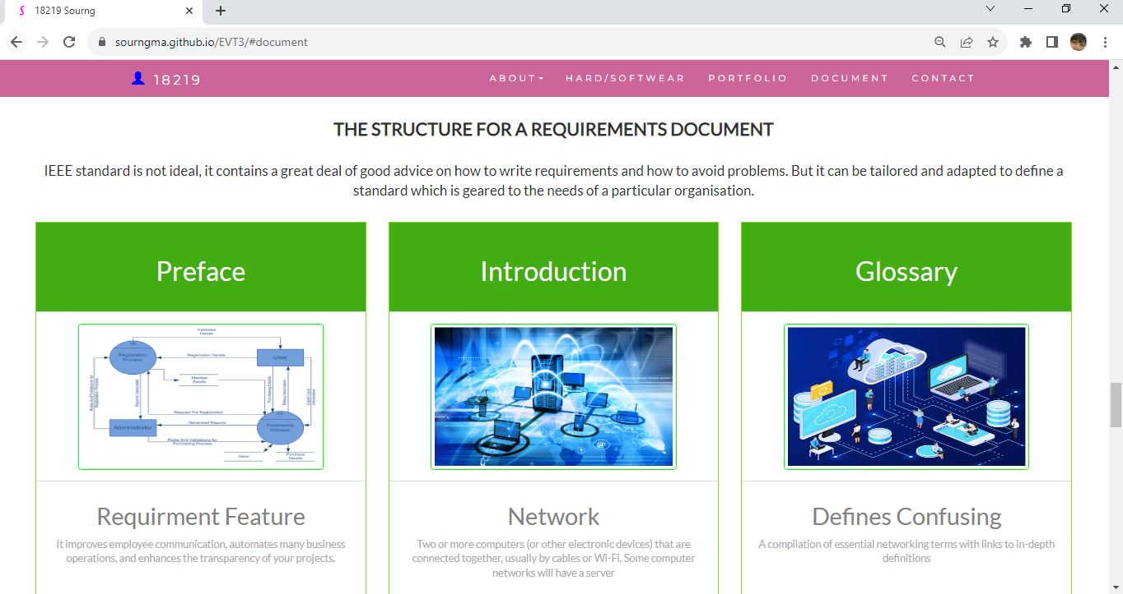

#### *Task 5: Short Answer Questions*

1. 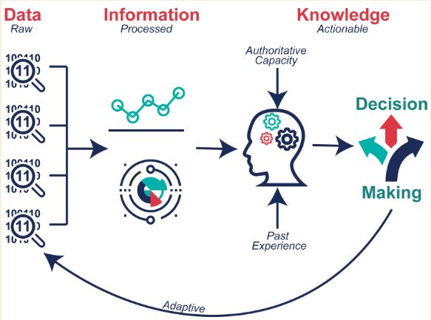Explain the relationship between data, information and knowledge.

Data is fact and raw material to generate information.

Information from data to get meaningful unions,

Knowledge is formed base on the information, information has various purposes in creating knowledge, decision making and guiding further action. Much knowledge and smarter, so we call wisdom.

1. What is quantitative data and how can you use it.

Quantitative data is used to quantify a problem and answer a question like “what”, “how many” and “how often”. We use it when do a research and used in math calculations, algorithms, or statistical analysis.

1. What is qualitative data and how can you use it.

Qualitative data provide means which analysts can qualify what around them and could use qualitative data to help and answer customers questions or problem facing. So we can solve the problem in a better way or provide the best solution.

1. 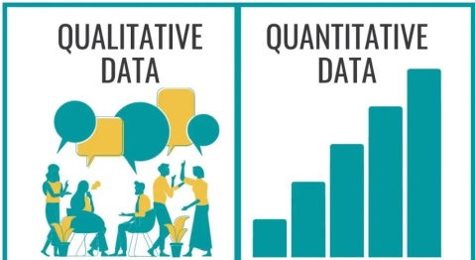Give an example of how quantitative and qualitative data can be used in conjunction with each other

Quantitative and qualitative data are gathering at the same time. For example, a study on student achievement may use both surveys and standardized test scores to gather data.

1. 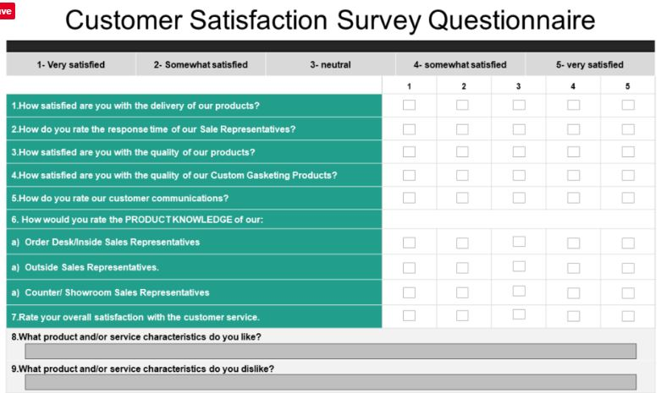What sort of methods could you use to determine client requirements for a website design and key information sources?

* Customer feedback
* Customer survey
* Customer support
* Customer service centre
* Etc.

1. Give some examples of client requirements for a website design

* Looks good
* 24 hours work
* Easy to update
* Upgrade is free

I made my web support page, could be accessed by: <https://sourngma.github.io/EVT3/#myPage>

#### *Task 6: Multiple Choice Questions*

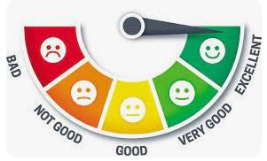

1. Generally, how many points should a rating scale have?
   1. Five
   2. Four
   3. Ten
   4. Somewhere from 4to 11 points the reason is that to scaling customer sanctification more detail and know the more specific in between good and bad rating to get right improving direction.

Web refers: <https://lumoa.me/blog/rating-scale>

A rating scale is a closed-end survey question that is used to evaluate how survey responders feel about a particular product or statement.

Comment: I like 10 points. It is easy and clear to get the best feedback way.

1. What is the problem(s) with this set of response categories to the question “What is your current age?”

* 1-5
* 5-10
* 10-20
* 20-30
* 30-40
  1. The categories are not mutually exclusive
  2. The categories are not exhaustive
  3. Both a and b are problems because people is sensitive to provide specific personal information like their specific age, so age range and inclusive is good enough to getting the data.
  4. There is no problem with the above set of response categories

1. You should mix methods in a way that provides complementary strengths and no overlapping weaknesses. This is known as the fundamental principle of mixed research.
   1. True because it provides the researcher with a logic for mixing quantitative and qualitative research approaches
   2. False
2. According to the text, questionnaires can address events and characteristics taking place when?
   1. In the past (retrospective questions)
   2. In the present (current time questions)
   3. In the future (prospective questions)
   4. All of the above To know all circumstances for the next correct direction action and analysis.
3. Which of the following are principles of questionnaire construction?
   1. Consider using multiple methods when measuring abstract constructs
   2. Use multiple items to measure abstract constructs
   3. Avoid double-barrelled questions
   4. All of the above
   5. Only b and c to get the right point and data we need, convenient and more efficient
4. Which of these is not a method of data collection?
   1. Questionnaires
   2. Interviews
   3. Experiments because we gather the raw data and the fact data, not any testing.
   4. Observations
5. Secondary/existing data may include which of the following?
   1. Official documents
   2. Personal documents
   3. Archived research data
   4. All of the above Because these are the data researcher’s needs and it is collected earlier by others.
6. An item that directs participants to different follow-up questions depending on their response is called a ____________.
   1. Response set
   2. Probe
   3. Semantic differential
   4. Contingency question Because contingency question only answered by some subgroup respondents or filter question. For instance, if you have your own car, how long have you owned it?
7. Which of the following terms best describes data that were originally collected at an earlier time by a different person for a different purpose?
   1. Primary data
   2. Secondary data because the data means collected by someone else earlier which specific what researcher’s needs.
   3. Experimental data
   4. Field notes
8. Researchers use both open-ended and closed-ended questions to collect data. Which of the following statements is true?
   1. Open-ended questions directly provide quantitative data based on the researcher’s predetermined response categories
   2. Closed-ended questions provide quantitative data in the participant’s own words
   3. Open-ended questions provide qualitative data in the participant’s own words because customers could express their own idea base on their own experience and conditions.
   4. Closed-ended questions directly provide qualitative data in the participants’ own words
9. Open-ended questions provide primarily ______ data.
   1. Confirmatory data
   2. Qualitative data Because we can get much data base on customers own words .
   3. Predictive data
   4. None of the above
10. Which of the following is true concerning observation?
    1. It takes less time than self-report approaches
    2. It costs less money than self-report approaches
    3. It is often not possible to determine exactly why the people behave as they do because sometime people just provide as general or base on theory but not the real behaviours.
    4. All of the above
11. Qualitative observation is usually done for exploratory purposes; it is also called ___________ observation.
    1. Structured
    2. Naturalistic because to gain a better understanding of phenomenon or situation.
    3. Complete
    4. Probed
12. When constructing a questionnaire, it is important to do each of the following except ______.
    1. Use "leading" or "loaded" questions because it could guide or leading answerer and can’t getting the fact data.
    2. Use natural language
    3. Understand your research participants
    4. Pilot your test questionnaire
13. Another name for a Likert Scale is a(n):
    1. Interview protocol
    2. Event sampling
    3. Summated rating scale it is the summary point of sanctification data we get.
    4. Ranking
14. Which of the following is not one of the six major methods of data collection that are used by educational researchers?
    1. Observation
    2. Interviews
    3. Questionnaires
    4. Checklists Because educational research looking for variety and open-ended data.
15. The type of interview in which the specific topics are decided in advance but the sequence and wording can be modified during the interview is called:
    1. The interview guide approach it’s like a guideline or procedure we can follow.
    2. The informal conversational interview
    3. A closed quantitative interview
    4. The standardized open-ended interview
16. Which one of the following in not a major method of data collection:
    1. Questionnaires
    2. Interviews We can ask as much as we need the data in various purpose.
    3. Secondary data
    4. Focus groups
    5. All of the above are methods of data collection
17. A question during an interview such as “Why do you feel that way?” is known as a:
    1. Probe Because some questions are related to personal or privacy.
    2. Filter question
    3. Response
    4. Pilot
18. A census taker often collects data through which of the following?
    1. Standardized tests
    2. Interviews
    3. Secondary data
    4. Observations Could get to know the tendency.
19. The researcher has secretly placed him or herself (as a member) in the group that is being studied. This researcher may be which of the following?
    1. A complete participant Him or herself was completed involve.
    2. An observer-as-participant
    3. A participant-as-observer
    4. None of the above
20. Which of the following is not a major method of data collection?
    1. Questionnaires
    2. Focus groups
    3. Correlational method It is a research in psychology.
    4. Secondary data
21. Which type of interview allows the questions to emerge from the immediate context or course of things?
    1. Interview guide approach
    2. Informal conversational interview because this interview is likely casual conversation.
    3. Closed quantitative interview
    4. Standardized open-ended interview
22. When conducting an interview, asking "Anything else?, What do you mean?, Why do you feel that way?," etc, are all forms of:
    1. Contingency questions
    2. Probes The reaction of being asked to providing too much personal information.
    3. Protocols
    4. Response categories
23. When constructing a questionnaire, there are 15 principles to which you should adhere. Which of the following is not one of those principles?
    1. Do not use "leading" or "loaded" questions
    2. Avoid double-barrelled questions
    3. Avoid double negatives
    4. Avoid using multiple items to measure a single construct because it’s not in the questionnaire principle.
24. A customer-based Service Level Agreement structure includes:
    1. An SLA covering all Customer groups and all the services they use
    2. SLAs for each service that are Customer-focused and written in business language
    3. An SLA for each service type, covering all those Customer groups that use that Service
    4. An SLA with each individual Customer group, covering all of the services they use --because it’s customer-based service.
25. Which of the following best describes the goal of Service Level Management?
    1. To maintain and improve IT service quality in line with business requirements , because maintain and improve it is the basic IT service should do.
    2. To provide IT services at the lowest possible cost by agreeing with Customers their minimum requirements for service availability and ensuring performance does not exceed these targets
    3. To provide the highest possible level of service to Customers and continuously improve on this through ensuring all services operate at maximum availability
    4. To ensure that IT delivers the same standard of service at the least cost
26. The process to implement SLAs comprises of the following activities in sequence:
    1. Draft SLAs, catalogue services, review underpinning contracts and OLAs, draft SLRs, negotiate, agree SLAs
    2. Draft SLAs, review underpinning contracts and OLAs, negotiate, catalogue services,
    3. Review underpinning contracts and OLAs, draft SLAs, catalogue services, negotiate, agree SLAs
    4. Catalogue services, establish SLRs, review underpinning contracts and OLAs, negotiate service levels, agree SLAs, because it’s the next action services would providing.
27. Which of the following is an example of a service level agreement (SLA) between information systems support unit and a research unit in the laboratories of a large company?
    1. The maximum response time to get the system operational should it fail.
    2. The minimum ‘up-time’.
    3. The types of information that will be provided as standard.
    4. All of the above. SLA are included maximum response, minimum up time and providing standard types of information.
28. Some organisations bring a degree of formality to the internal customer concept by encouraging (or requiring) different parts of the operation to agree on:
    1. Internal service agreements
    2. Service level agreements because to leverage and provide service base on its degree.
    3. Formal provision agreements
    4. Delivery agreements

## Index

B

bookstore 3

C

categories 10

closed-ended 12

D

data collection 13

L

Linux server 3

N

negative experience 6

network 3

O

open-ended 12

S

Service Level 14

service level agreement 15

service quality 14

soft skills 8

support 6

T

technology 4

telecommunications 6